Regenerative Braking Control with Bidirectional Inverter for EV Applications
Hüseyin KURT*
Department of Electrical-Electronics Engineering, Istanbul Aydin University, Istanbul, Turkey
huseyinkurt1@aydin.edu.tr

Abstract
Regenerative braking is a critical function in electric vehicles (EVs) for enhancing energy efficiency and extending driving range. This paper presents a regenerative braking control strategy for a permanent magnet synchronous motor (PMSM) drive system, utilizing a bidirectional buck-boost converter integrated with a full-bridge inverter. The proposed method utilizes a bidirectional buck-boost converter to maximize energy recovery and ensure safe deceleration across varying operating conditions. A field-oriented control (FOC) scheme is employed for precise torque and flux control, while a supervisory logic dynamically selects the converter mode based on real-time motor torque conditions. The entire system is modeled and simulated in MATLAB/Simulink, including realistic battery dynamics and flat road condition. Simulation results demonstrate that the proposed approach significantly improves energy recovery efficiency and maintains motor stability. This enables effective braking at low speeds where traditional regenerative strategies are ineffective.
Keywords: Regenerative braking control, bidirectional buck-boost converter, field-oriented control, SVPWM, PMSM, electrical vehicle

1. Introduction
The rising adoption of electric vehicles (EVs) has placed increasing importance on energy efficiency and battery longevity (Chan, 2007; Tie & Tan, 2013). Regenerative braking (RB) has emerged as a key technique for improving energy utilization by recovering kinetic energy during deceleration and storing it back into the battery system (Li, Wang, Li, & Mi, 2016; Jain & Agarwal, 2018). However, conventional RB methods are often limited in low-speed scenarios due to inadequate back-EMF generation (Zhang & Emadi, 2005; Yuan & Zhang, 2019). Permanent Magnet Synchronous Motors (PMSMs) are widely adopted in EV applications due to their high efficiency, power density, and superior torque characteristics (Chau, Chan, & Liu, 2008; Zhu & Howe, 2007). However, the control of PMSMs during regenerative braking introduces several technical challenges, particularly when considering bidirectional energy flow between the battery and motor under dynamic driving conditions (Liu & Mi, 2012; Jain & Shrivastava, 2020). These challenges become more pronounced when the system is expected to switch seamlessly between motoring and regenerative modes without compromising performance or stability (Chien & Chang, 2018). In conventional regenerative systems, a unidirectional control strategy is often employed, which limits the energy recovery potential and fails to optimize the charging dynamics of the battery across road scenarios (Ali & Yousuf, 2019; Jogi & Babu, 2020). To address these limitations, this study proposes a regenerative braking system based on a bidirectional cascaded DC-DC converter interfaced with a full-bridge inverter (Kumar & Jain, 2017). The dual-mode architecture enables two distinct operating strategies: (1) Boost mode during braking, allowing energy recovery by elevating the DC-link voltage for effective battery charging(Zheng & Yu, 2019) and (2) Buck mode during acceleration, facilitating controlled battery discharge for propulsion (Kumar & Singh, 2016). A Field-Oriented Control (FOC) strategy is integrated to ensure precise torque and flux regulation of the PMSM (Ehsani, Gao, Gay, & Emadi, 2005).

2. Methodology
This section presents the modeling, design, and control approach for the regenerative braking system for a PMSM-based electric vehicle at low speed. The MATLAB Simulink simulation model consists of a bidirectional DC-DC converter, an SVPWM inverter for PMSM drive, and FOC algorithm. 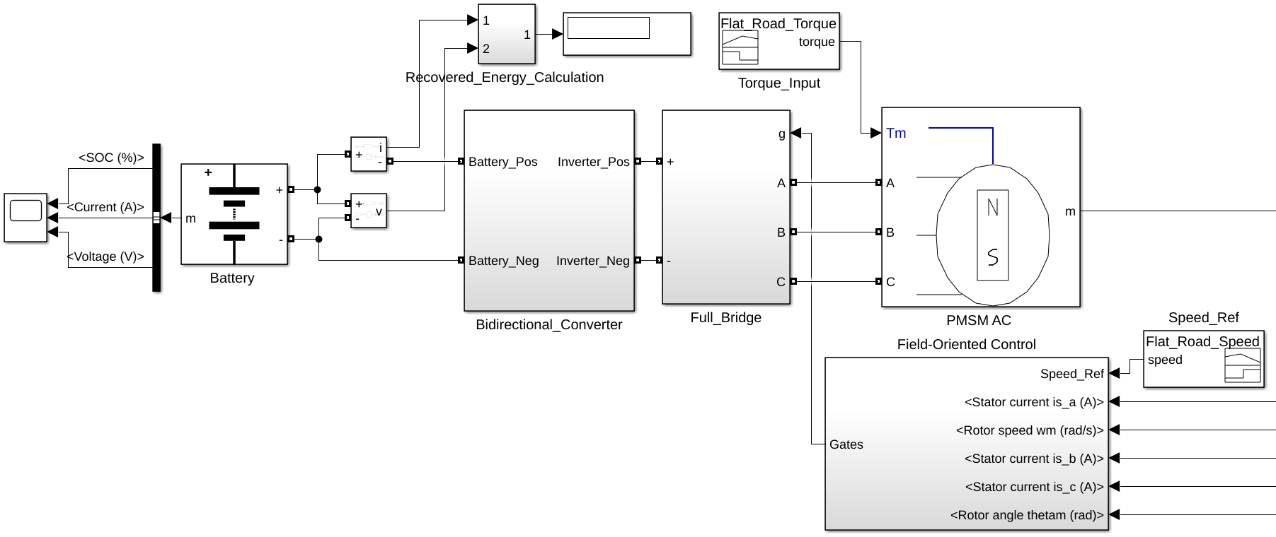
Figure X1. Regenerative braking model blocks.
The components of simulation are; a lithium-ion battery pack serving as the DC energy source and sink, a bidirectional DC-DC converter capable of operating in both buck (regenerating) mode and boost (motoring) mode, a full-bridge inverter for AC excitation of the PMSM, a PMSM as the traction motor.
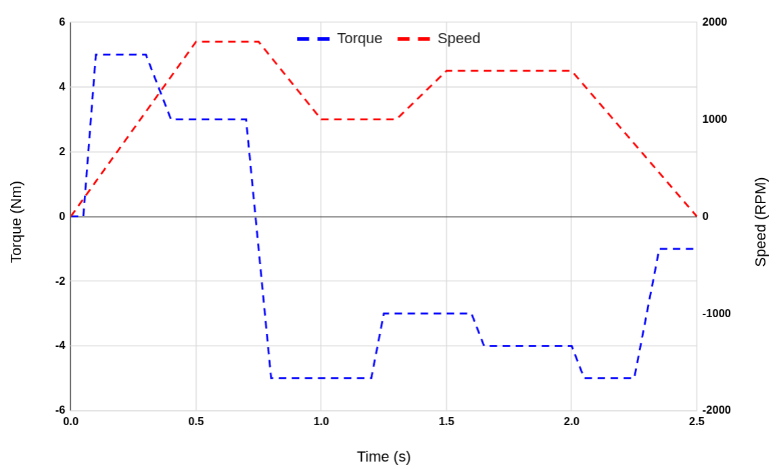
Figure X2: Road torque and reference speed loaded to the PMSM motor.
The reference speed values presented in figure 1 are specified for low-speed operation (≤ 20 km/h), while the torque value is determined under a flat road profile condition.
$Speed (km/h) =\frac{Motor RPM}{Gear Ratio}×π×D_{wheel}×\frac{60}{1000}$ (1)
Where:
- $Motor RPM$ = Motor speed in revolutions per minute
- $Gear Ratio$ = Total reduction (motor turns / wheel turns)
- $D_{wheel}$ = Wheel diameter in meters
- $\frac{60}{1000}$ = ​Converts meters/min to km/h
Simulation reference speed changes between 0 km/h and 20.36 km/h (0 RPM to 1800 RPM) as calculated equation 1.
The PMSM is controlled using the Field-Oriented Control (FOC) technique for both motoring and regenerative modes. The FOC algorithm consists of; Clarke and Park transformations to convert stator currents from three-phase to d-q rotating reference frame, PI controllers for torque and flux control via $i_{d}$ and $i_{q}$​ currents, Space Vector PWM (SVPWM) for inverter switching pattern generation.
Table 1: Parameter of model.
Parameter | Value
Motor nominal voltage | 300 Vdc
PMSM rated power | 2830 W
Converter capacitance | 1000 µF
Converter inductance | 1 mH
Converter switching freq | 5 kHz
Battery nominal voltage | 280 V
Rated capacity (Ah) | 12 Ah
Wheel radius | 0.3 m
Gear ratio | 10

Simulated model parameters are shown at table 1. Rated values of chosen motor in Simulink are 6 Nm, 300 Vdc and 4500 RPM. Vehicle wheel radius 0.3 m and weight of this vehicle is 1200 kg.

3. Simulation and Results
The proposed model was simulated during 2.5 seconds. A key innovation in this study is the implementation of converter control governed by real-time motor torque. Working mode are defined as;
If $T_{e}>0$: Motoring phase → Boost mode,
If $T_{e}<0$: Regenerative braking phase → Buck mode,
Where $T_{e}$ is motor electrical torque.
Buck mode is the regenerating phase in which energy flows from DC link voltage (high voltage) to battery voltage (low voltage) to charge the battery in the braking situation. The battery voltage and converter capacitance (C) and inductance (L) values are calculated for buck mode as follows:
$V_{B}=V_{DC}×D$ (1)
$C=\frac{(1-D)V_{B}}{8LΔV_{B}f}$
$L=\frac{D(V_{DC}-V_{B})}{ΔI_{L}f}$
Boost mode is driving the motor. The energy flows from Battery to motor. The DC link voltage and capacitance and the inductance values are calculated as follows:
$V_{DC}=\frac{V_{B}}{(1-D)}$
$C=\frac{D×V_{DC}}{R_{out}ΔV_{DC}f}$
$L=\frac{V_{B}×D}{ΔI_{L}f}$, where
L and C are calculated separately for buck and boost mode. Bidirectional Converter L and C values are separately defined by taking the maximum calculated values for these two modes.
In this study, the monitored key assessment system performance is battery state-of-charge (SOC), system recovered energy and speed and torque responses.

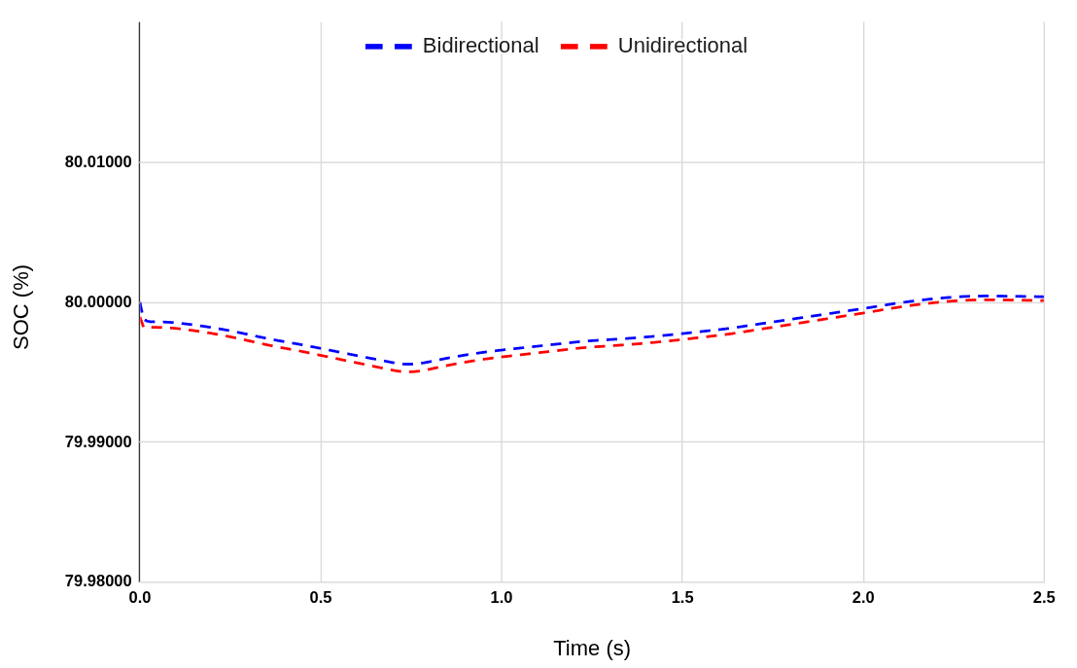
Figure X3 : The proposed system Speed response to.
Both converters regenerate the energy under negative torque. However, the bidirectional converter is much more than the unidirectional converter to keep the energy.
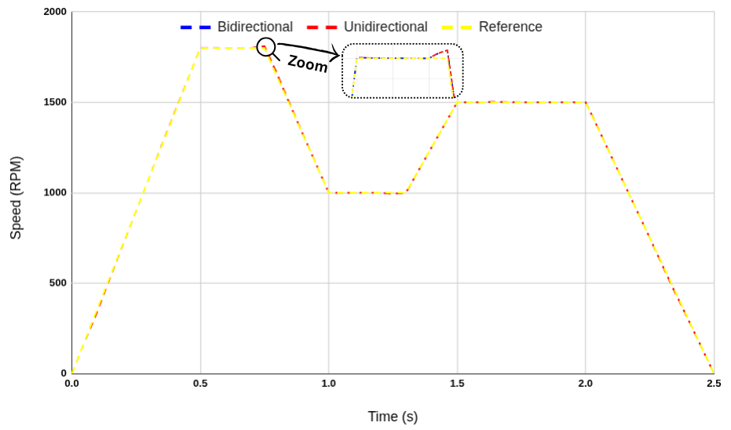
Figure X4 : Reference, unidirectional and bidirectional converter speed responses.
Figure X4 shows the reference and compared converters speed response during the used road profile. Speed response according to reference speed, both are better because for both converters use the FOC controller with PI controller.
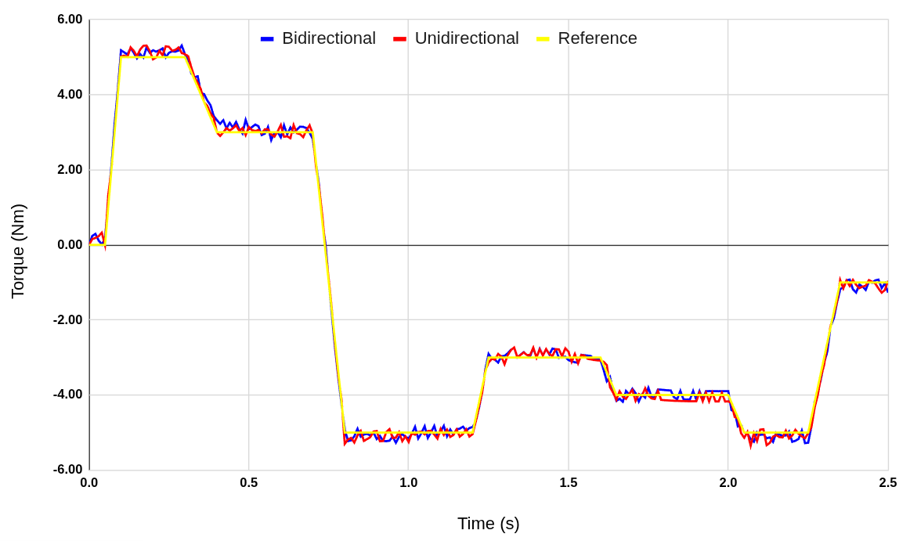
Figure X5: The proposed system Speed response to.
Figure X5 indicates the response of two type converters to applied torque. During braking, the torque becomes negative, triggering boost mode and initiating energy recovery. Smooth transition between acceleration and regenerative braking phases confirms effective dual-mode operation.
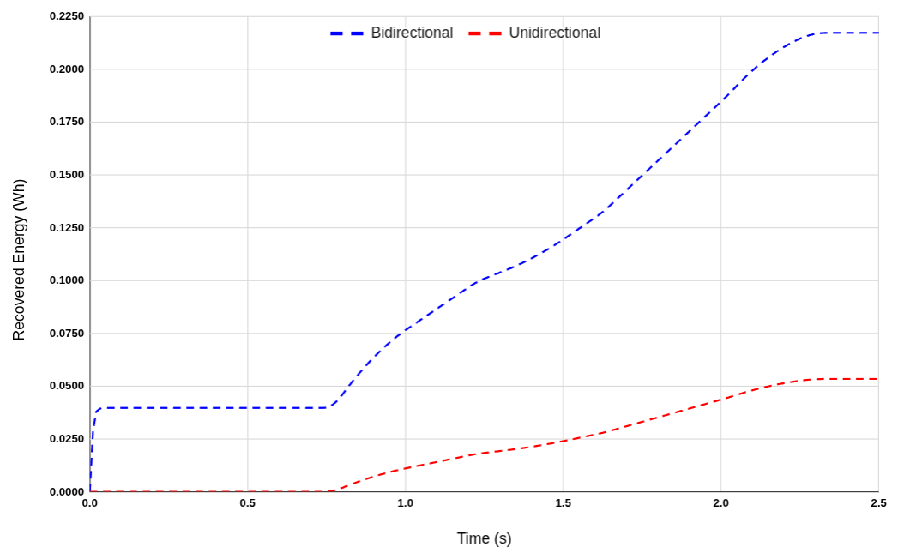
The proposed bidirectional converter strategy is compared with a baseline unidirectional converter.
Table 2: Recovered Energy
Converter Type | Average Regenerative Power (W) | Total Energy Recovered (Wh)
Bidirectional | 312.91 W | 0.2173 Wh
Unidirectional | 256.46 W | 0.1781 Wh

Bidirectional converter recovered the energy about 0.2173 Wh during 2.5 seconds while unidirectional converter recovered 0.1781 Wh. This implies that the proposed bidirectional converter regenerates the energy about 22.01% more. These results validate the effectiveness of the proposed regenerative control strategy. The intelligent mode-switching logic ensures efficient energy flow management and seamless operation without introducing torque ripple or system instability. These results suggest strong potential for real-world implementation with improved EV range and energy efficiency.

Conclusion
This paper presented a dual-mode regenerative braking control strategy for a PMSM-based electric vehicle drivetrain utilizing a bidirectional cascaded DC-DC converter. By integrating this converter topology with a field-oriented control (FOC) scheme, the system enables efficient bidirectional power flow management between the motor and the battery.
The simulation results, validated across flat road driving scenarios at low speed, demonstrated the superior energy recovery capability of the proposed approach. Compared to conventional converters for regenerative braking systems, the bidirectional converter strategy improved energy recovery by more than 22.01%, while maintaining system stability, DC bus voltage regulation, and smooth torque transitions.
The successful implementation of the dual-mode converter logic in MATLAB/Simulink confirms the feasibility of this architecture for real-world applications. The approach not only enhances energy efficiency and battery state-of-charge (SOC) management but also contributes to extending the operational range of electric vehicles without adding significant system complexity.

References
Chan, C. C. (2007). The state of the art of electric, hybrid, and fuel cell vehicles. Proceedings of the IEEE, 95(4), 704–718. https://doi.org/10.1109/JPROC.2007.892489
Ehsani, M., Gao, Y., Gay, S. E., & Emadi, A. (2005). Modern electric, hybrid electric, and fuel cell vehicles: Fundamentals, theory, and design (2nd ed.). CRC Press.
Liu, J., & Mi, C. C. (2012). Power electronics for electric vehicles and hybrid electric vehicles. Wiley-IEEE Press.
Chau, K. T., Chan, C. C., & Liu, C. (2008). Overview of permanent-magnet brushless drives for electric and hybrid electric vehicles. IEEE Transactions on Industrial Electronics, 55(6), 2246–2257. https://doi.org/10.1109/TIE.2008.921602
Tie, S. F., & Tan, C. W. (2013). A review of energy sources and energy management system in electric vehicles. Renewable and Sustainable Energy Reviews, 20, 82–102. https://doi.org/10.1016/j.rser.2012.11.077
Ali, S., & Yousuf, M. (2019). Comparative analysis of regenerative braking systems. Energy Reports, 5, 1413–1423. https://doi.org/10.1016/j.egyr.2019.09.010
Li, L., Wang, Y., Li, J., & Mi, C. C. (2016). Online optimal control of regenerative braking for electric vehicles. IEEE Transactions on Vehicular Technology, 65(7), 5439–5448. https://doi.org/10.1109/TVT.2015.2475741
Zhang, Y., & Emadi, A. (2005). Impact of regenerative braking on vehicle performance—Comparative analysis of different electric propulsion systems. IEEE Transactions on Vehicular Technology, 54(6), 1613–1619. https://doi.org/10.1109/TVT.2005.858010
Yuan, W., & Zhang, H. (2019). Bidirectional DC–DC converter design for regenerative braking energy recovery. Journal of Power Electronics, 19(5), 1336–1345.
Jain, P., & Agarwal, A. (2018). Regenerative braking in electric vehicles using bidirectional DC-DC converter: A review. International Journal of Power Electronics and Drive Systems, 9(4), 1860–1871.
Jogi, A. V., & Babu, T. R. (2020). A review on bidirectional DC–DC converters for regenerative braking in electric vehicles. International Journal of Electrical and Computer Engineering, 10(5), 5015–5022.
Zhu, Z. Q., & Howe, D. (2007). Electrical machines and drives for electric, hybrid, and fuel cell vehicles. Proceedings of the IEEE, 95(4), 746–765. https://doi.org/10.1109/JPROC.2007.892482
Kumar, N., & Jain, A. (2017). Dual-mode DC–DC converter with regenerative braking for electric vehicle applications. International Journal of Electronics, 104(8), 1366–1382.
Jain, R., & Shrivastava, V. (2020). Regenerative braking system using fuzzy logic controller for electric vehicle. International Journal of Intelligent Engineering and Systems, 13(3), 221–230.
Chien, T. H., & Chang, C. C. (2018). Adaptive regenerative braking control strategy for electric vehicles. International Journal of Automotive Technology, 19(3), 457–464.
Kumar, R., & Singh, B. (2016). Power quality improvement in electric vehicle using bidirectional converter. IEEE Transactions on Industrial Applications, 52(5), 4137–4145.
Zheng, Y., & Yu, H. (2019). Control of electric braking torque for regenerative braking systems. IEEE Access, 7, 130984–130992. https://doi.org/10.1109/ACCESS.2019.2939914

